
Year 4 - Autumn 1
Animals Including Humans

Scientists Link


William Beaumont

Sticky Knowledge

- Humans have 4 types of teeth: Incisors are used for biting and cutting, canines used for ripping and tearing, premolars and molars are for grinding and chewing
- A food chain shows how plants and animals get their energy
- A producer gets its energy from the sun but a consumer eats other plants and animals to get energy
Scientific Diagrams

Key Vocabulary | Definition
Digestive system | The organs in your body involved in the digestion of food.
Digestion | The way the body breaks down food so the body can absorb it.
Oesophagus | The tube that leads from the mouth to the stomach
Stomach | The organ into which food mixes and digests before passing to the small intestine
Small intestine | Where food is digested into small molecules which are absorbed into the body
Large intestine | Takes water and some minerals from the leftover food material and creates solid waste
Producers | An organism that makes its own food
Prey | Animals that ate eaten by a predator
Predators | Animals that eat other animals. They are top of the food chain
Consumer | Eats producers or other consumers in a food chain

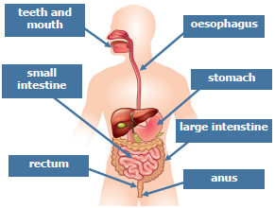

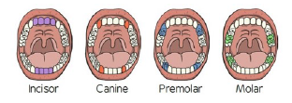

Lesson 3
Can I identify the types and functions of teeth?
Lesson 2
Can I explain the functions of the digestive system?
Lesson 1
Can I identify and name parts of the human digestive system?
Lesson 4
Can I ask scientific questions and choose a scientific enquiry to answer them?

Lesson 6
Can I construct and interpret food chains?

Lesson 5
Can I make observations, record results and write a conclusion?

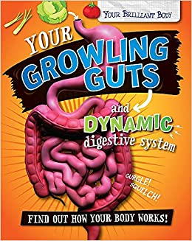
Link to a text

Your Growling Guts and Dynamic Digestive System
By Paul Mason

