
Year 4 Autumn 2 – Sound

Scientists Link



Marin Mersenne

Sticky Knowledge

- Sounds are made when objects vibrate. The vibration makes the air around the object vibrate and the air vibrations enter your ear.
- You can’t always see vibrations, but if something is making a sound, some part of it is always vibrating.
- Sound waves can travel through solids (such as metal, stone and wood) liquids (such as water) and gases (such as air).
Scientific Diagrams

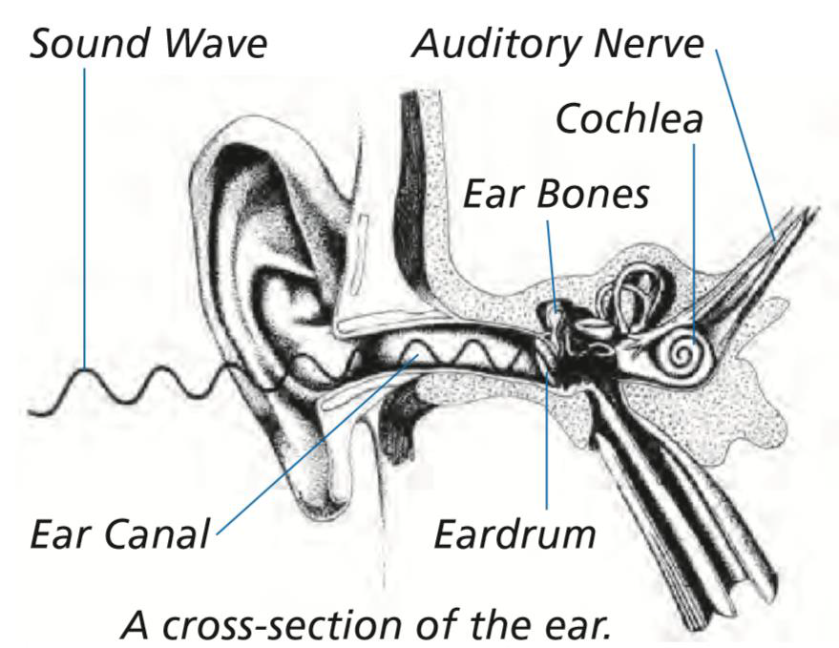

Sound Waves
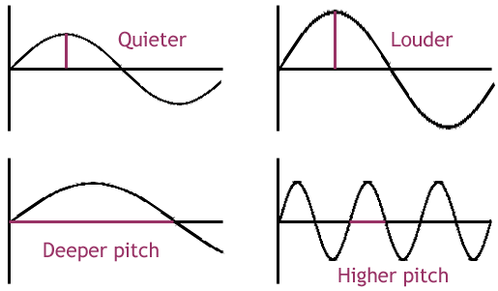
Key Vocabulary | Definition
Vibration | A back and forth movement
Sound waves | A wave that moves through the air when a sound is made, carrying the sounds to our ears
Pitch | How high or low a sound is
Volume | How loud or quiet a sound is
Larynx | Your voice box, which is in your throat. The larynx vibrates to make sound.
Break the sound barrier | When a vehicle begins to travel faster than sound

Lesson 3
Can I begin to understand that sounds can vary in pitch and volume?
Lesson 2
Can I explain that sounds are made when an object vibrates?
Lesson 1
Can I ask and answer questions about the sound that can be heard and begin to consider how sounds are made?
Lesson 4
Can I ask and answer questions about the hearing of humans and other animals?

Lesson 6
Can I find results from the investigation and demonstrate an understanding of how sound travels?

Lesson 5
Can I investigate sound-proofing materials by panning and conducting a fair test?

Link to a text

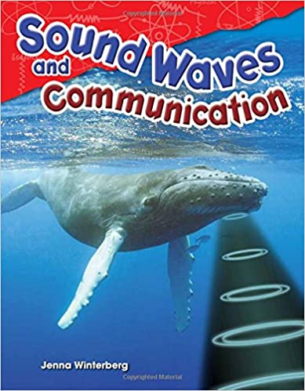
Sound Waves and Communication
By Jenna Winterberg

