
Year 4 Spring 1 – States of Matter

Key Vocabulary | Definition
Change of state | When a material changes from one state to another
Melting | The change of state from solid to liquid
Freezing | The change of state from liquid to solid. When a liquid becomes cold enough to turn solid it freezes. The freezing point of water is 0 ‘c.
Meting Point | The temperature at which a solid becomes a liquid. The melting point of water is 0’c.
Boiling Point | The temperature at which a liquid turns into a gas. Water boils when it is heated to 100’c.
Evaporation | The change from a liquid to a gas at the surface of the liquid.
Condensation | The process when a gas changes into a liquid, caused by cooling.
Water Cycle | The never ending process of water moving from the oceans, up into the atmosphere and back to Earth and oceans.
Temperature | The measure of how hot or cold something is. It is measured in degrees Celsius with a thermometer

Scientists Link
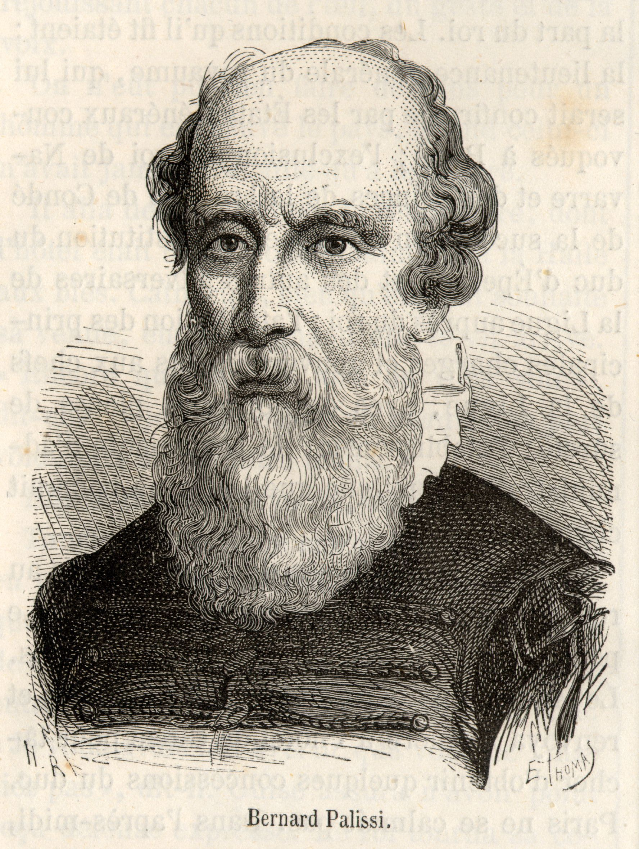
Bernard Palissy

Sticky Knowledge

A solid keeps its shape and has a fixed volume

A liquid has a fixed volume but changes in shape to fit the container. It can be poured.

A gas fills all the available space; it has no foxed shape or volume.

Scientific Diagrams

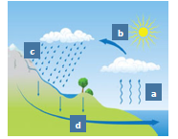

- Evaporation
- Condensation
- Precipatation
- Collection

Lesson 3
Can I observe that materials change state when they are heated or cooled?
Lesson 2
Can I identify and explore the properties of gases?
Lesson 1
Can I compare and group materials together according to whether they are solids or liquids?
Lesson 4
Can I research the temperature at which materials change state?

Lesson 6
Can I identify the four processes of the water cycle?

Lesson 5
Can I understand the process of evaporation and condensation?

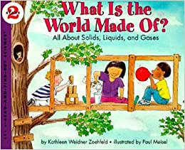
Link to a text

What is the world made of?
By Kathleen Weidner Zoehfeld

