
Year 4 Spring 2 – Electricity

Scientists Link
Nikola Tesla
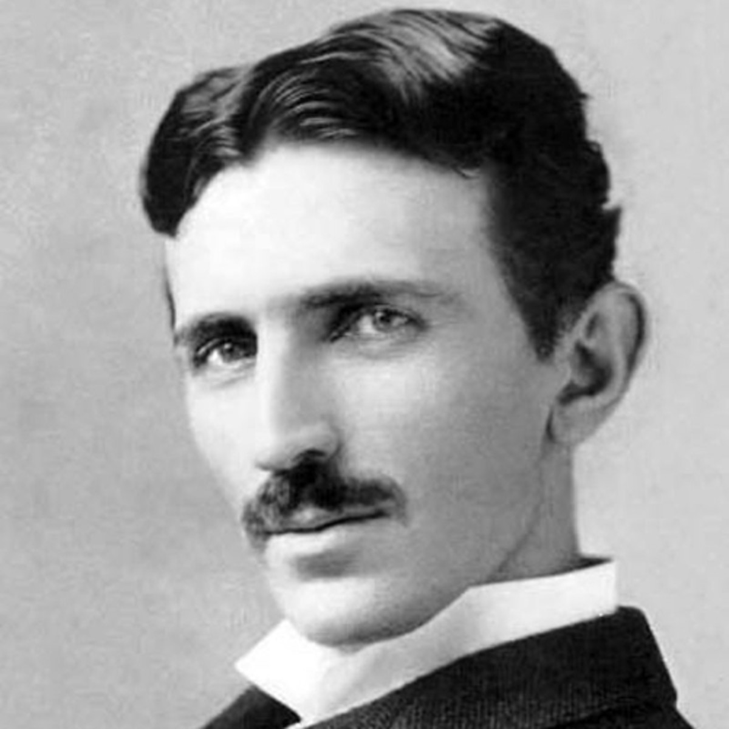
Sticky Knowledge
- Copper, steel, gold, aluminium, and brass are good conductors of electricity.

- Good insulators of electricity include; plastics, paper, rubber, glass and dry air.

- A series circuit is a closed circuit in which the current follows one path,

Scientific Diagrams

Series circuit
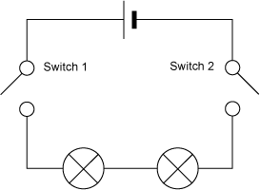

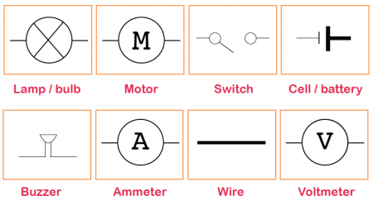

Key Vocabulary | Definition
Fuse | A safety device to stop the flow of electricity.
Series circuit | A complete closed circuit that runs through one path.
Open switch | An open switch makes an incomplete circuit not allowing current to pass through.
Closed switch | Completes a circuit allowing current to pass through.
Current | The rate at which electricity flows.
Insulator | Does not readily conduct electricity.
Conductor | Contains electrical charge.
Cell | A device capable of changing chemical energy into electrical current.
Battery | A device that stores chemical energy and converts it into electrical current.
Amps | Unit of electrical current.
Volts | Unit of electrical force.

Lesson 3
Can I create a series circuit?
Lesson 2
Can I identify insulators and conductors?
Lesson 1
Can I identify electrical appliances?
Lesson 4
Can I draw and explain a series circuit?

Lesson 6
Can I write an information text Nikola Tesla?

Extended writing opportunity.

Lesson 5
Can I create a set of instructions to build a series circuit?

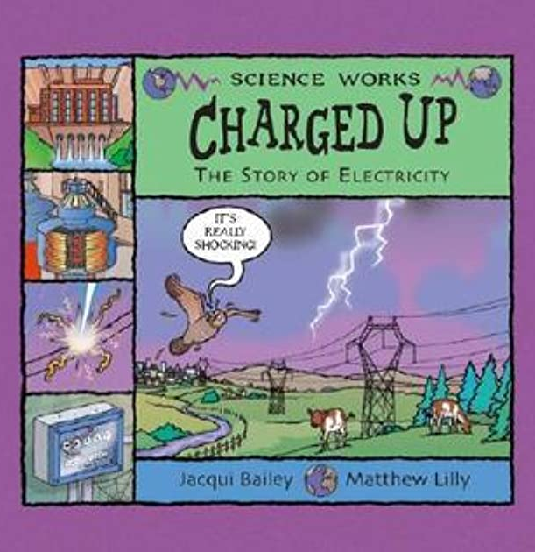
Link to a text

Charged Up: The Story of Electricity
By Jacqui Bailey

