
Year 4 Summer 1 – Living Things and their habitats

Scientists Link
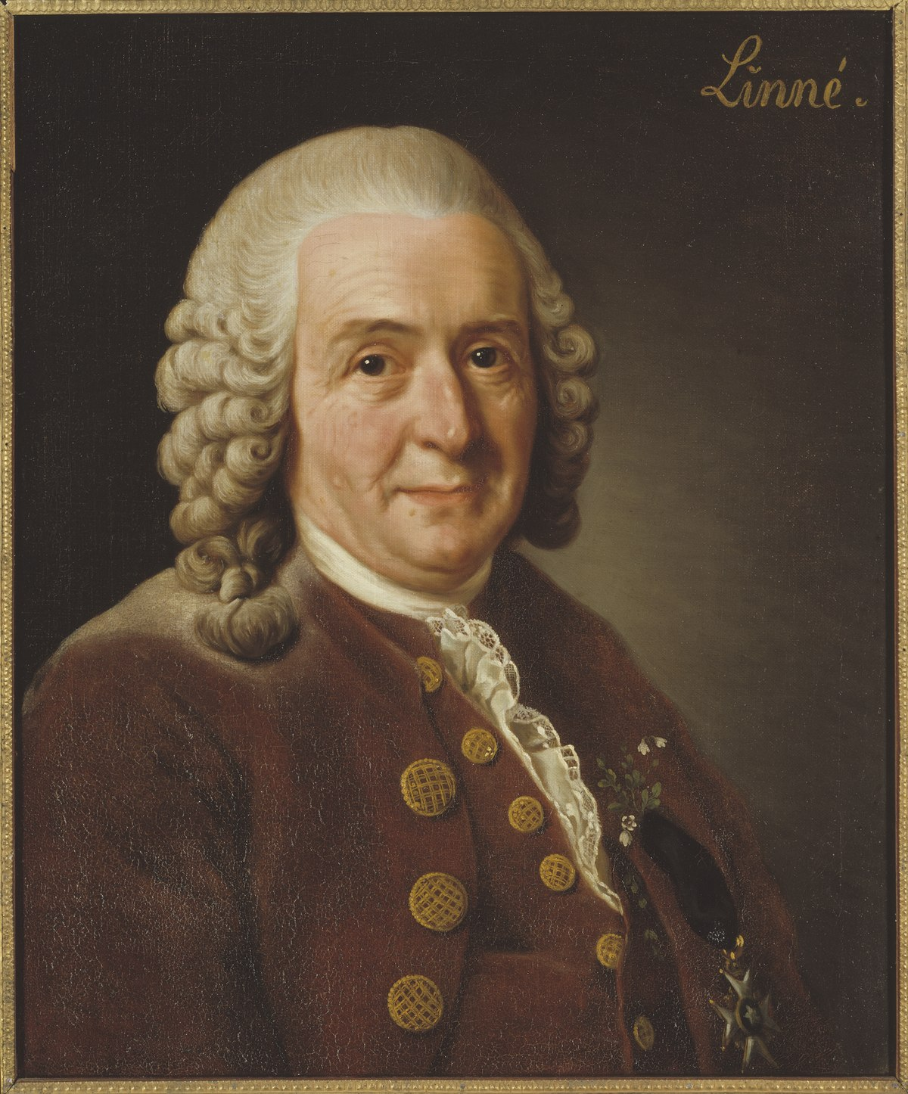

Carl Linnaeus

Sticky Knowledge
- Environments can change for 2 reasons: Natural or Human Impact.

- Flooding, fire, earthquakes etc cause natural environmental changes.

- Human impact can be negative such as littering, deforestation, air pollution and plastics in the oceans. Or it can be positive such as nature reserves, tree planting, creating a garden pond
Scientific Diagrams

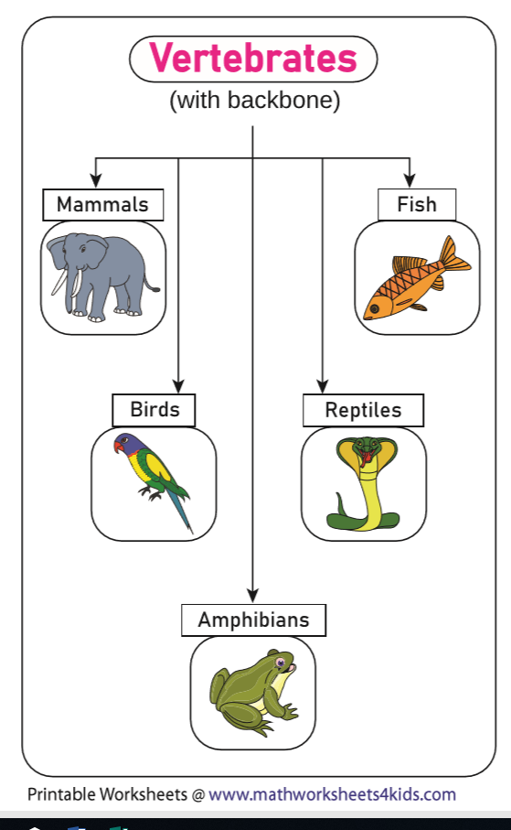
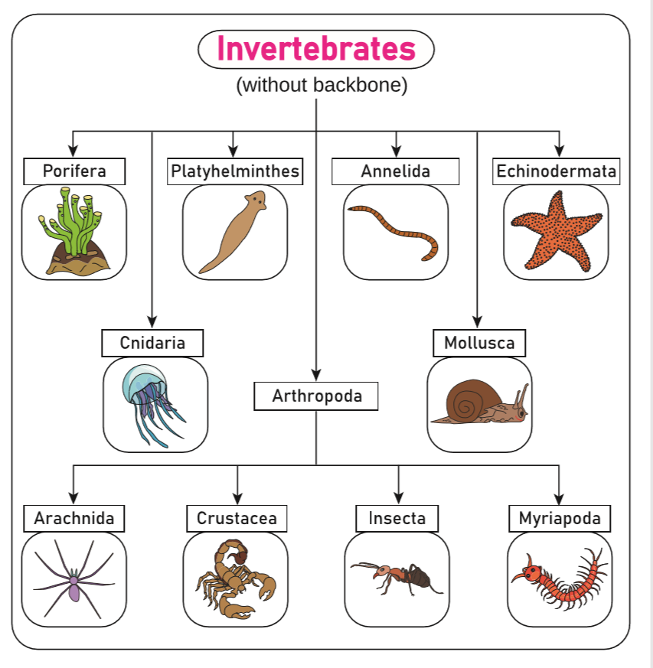

Key Vocabulary | Definition
Characteristic | A quality or appearance that makes an individual or group different from others
Classification | Grouping things based on their characteristics so they can be identified
Environment | The conditions in which a living thing exists. Soil, climate and other living things all count as part of the environment.
Hibernate | An animal or plant that spends the winter in a dormant state
Migrate | The long distance movement of animals, usually due to a change in the seasons
Invertebrate | An animal that does not have a backbone such as snails, worms, spiders and insects
Vertebrate | An animal that has a backbone such as fish, amphibians, reptiles, birds and mammals

Lesson 3
Can I identify invertebrates in the local environment?
Lesson 2
Can I identify vertebrates by observing their similarities and differences?
Lesson 1
Can I use a range of methods to sort living things?
Lesson 4
Can I create a classification key to show characteristics of living things?

Lesson 6
Can I describe environmental dangers to endangered species?

Lesson 5
Can I recognise positive and negative changes to the local environment and record my observations?

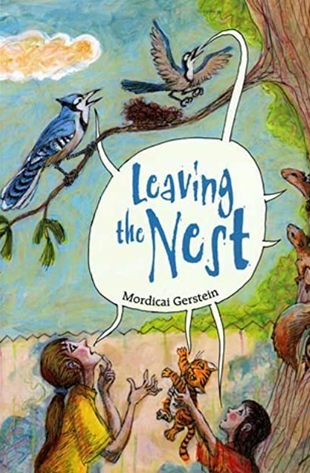
Link to a text

Leaving the Nest
By Mordicai Gerstein

