
Year 4 Summer 2 – Environmental Science

Sticky Knowledge
Forest ecosystems are important because it protects plant, animal and insects. It also protects the forest floor, which slows down soil erosion.
- Deforestation has a negative affect on the water cycle, climate change, biodiversity and soil when it exposed to the sun’s heat.

Recycling materials such as paper, glass and plastic can support the environment and reduces the need for raw materials so that that rainforests can be preserved.
Scientists Link

Rachel Carson

Rachel Carson
Scientific Diagrams

Deforestation

Ecosystem

Key Vocabulary | Definition
Environment | The conditions in which a living thing exists. Soil, climate and other living things all count as part of the environment.
Deforestation | The action of clearing a wide area of trees.
Recycling | The process of converting waste into reusable material.
Litter | Rubbish such as paper, cans and bottles left lying in an open or public place.
Air pollution | A substance in the air which has harmful or poisonous effects.
Ecosystem | A community of animals, plants and mirco-organisms together with their habitat creates an ecosystem.

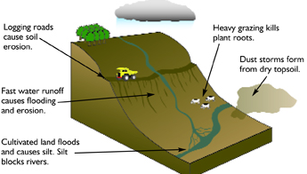

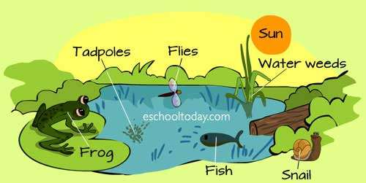

Lesson 3
Can I explore the affects of littering in the local area?
Lesson 2
Can I identify the positive and negative impact of deforestation?
Lesson 1
Can I understand the importance of rainforests?
Lesson 4
Can I understand why we recycle and how it supports the environment?

Lesson 6
Can I ask and answer questions about air pollution?

Lesson 5
Can I raise awareness about deforestation and promote recycling?

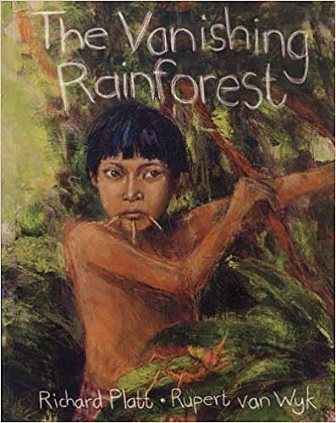
Link to a text

The Vanishing Rainforest
By Richard Platt

