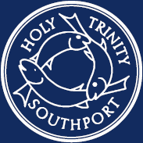
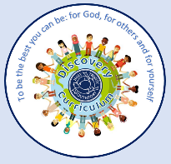
DISCOVER the PSHE/RSE offer at Holy Trinity
To be the best we can be: for God, for others and for ourselves

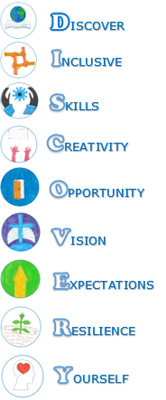 |   Spiritual Opportunities  - To nurture a sense of self-worth, self-identity and personal responsibility so that children can begin to learn how to make sound moral, social, spiritual and cultural choices  - To cultivate awareness of living in an inter connected world and of being a “world citizen”  - To develop an awareness of the shared values of communities and where there might be conflicting values.  - To respect and value diversity |  |  | 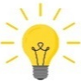  Intent Statement  NHS My Happy Mind RSE/PSHE scheme of work covers the Relationships and Health Education statutory guidance (as set out by the Department for Education). The scheme covers wider PSHE learning, in line with the requirement of the National curriculum (2014) that schools ‘should make provision for personal, social, health and economic education (PSHE).’ Children’s learning through this scheme would significantly contribute to their personal development as set out in the Ofsted Inspection Framework and promotes the four fundamental British values which reflect life in modern Britain: democracy; rule of law; respect and tolerance and individual liberty. Quality PSHE and RSE teaching is an important element in helping schools to carry out their duty of care with regards to safeguarding. The DfE’s statutory ‘Keeping Children Safe in Education (Sep 2025)’. In response to the child-on-child abuse updates to Section 5 of Keeping Children Safe in Education (DfE, 2022), our curriculum introduces and revisits ideas of personal boundaries, consent and communicating our boundaries with others. This prepares pupils for the challenges and responsibilities they will face in the future. |  |  | 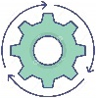  Implementation and Key content  The NHS My Happy Mind Programme is a whole school approach. The main themes that are revisited throughout our school year groups are:  - Meet Your Brain  - Celebrate  - Appreciate  - Relate  - Engage  Each area is revisited to allow children to build on prior learning. The lessons also provide a progressive programme. The lessons are based upon the statutory requirements for Relationships and Health education.  Holy Trinity CE Primary School also uses My Happy Mind Plus teaching materials to ensure compete coverage of the Statutory Guidance for Relationships Education. The programme also includes the Non-Statutory PSHE objectives therefore providing a well rounded curriculum for pupils.  These additional materials include:  - My Happy Body – Core Theme 1: Health and Well Being  - My Happy Relationships – Core Theme 2: Relationships  - My Happy World – Core Theme 2: Living in the Wider World  My Happy Mind + maintains the same engaging look and feel as the original My Happy Mind lessons ensuring consistency across the Key Stages.
  EYFS  Children’s personal, social and emotional development (PSED) is crucial for children to lead healthy and happy lives, and is fundamental to their cognitive development. Underpinning their personal development are the important attachments that shape their social world. Strong, warm and supportive relationships with adults enable children to learn how to understand their own feelings and those of others. Children should be supported to manage emotions, develop a positive sense of self, set themselves simple goals, have confidence in their own abilities, to persist and wait for what they want and direct attention as necessary. Through adult modelling and guidance, they will learn how to look after their bodies, including healthy eating, and manage personal needs independently. Through supported interaction with other children, they learn how to make good friendships, co-operate and resolve conflicts peaceably. These attributes will provide a secure platform from which children can achieve at school and in later life. |  |  |   Cultural Capital  The teaching of PSHE/RSE should provide children with the cultural capital that they will need to succeed in their lives beyond primary education. Through visits, visitors and discussions of current affairs, children should become engaged with the world around them, at a local, national and international level. We want our pupils to develop a sense of agency and responsibility, as well as pride in their local community. |  |  |  | 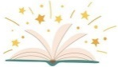  Reading is the Passport to the World!  At Holy Trinity we ensure high quality texts are embedded in our PSHE/RSE curriculum to build contextual knowledge to link learning and to support reading for meaning.  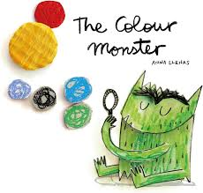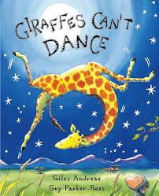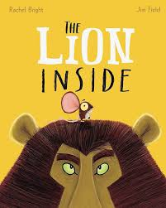  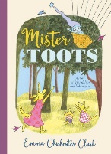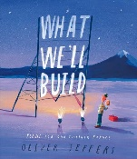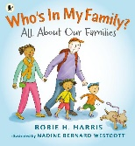
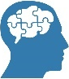  Pedagogical approach to Teaching and Learning (lesson structure)  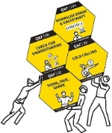  Use of the NHS My Happy Mind Plus programme including lesson presentations and recording in journals. Children and Parents have access to My Happy Mind app at home to continue their learning and share with parents. Teaching and learning is supported by Rosenshine’s Principles of Instruction (Review, Check for understanding, Provide Models, Provide Scaffolds). |  |  |  |  |  | 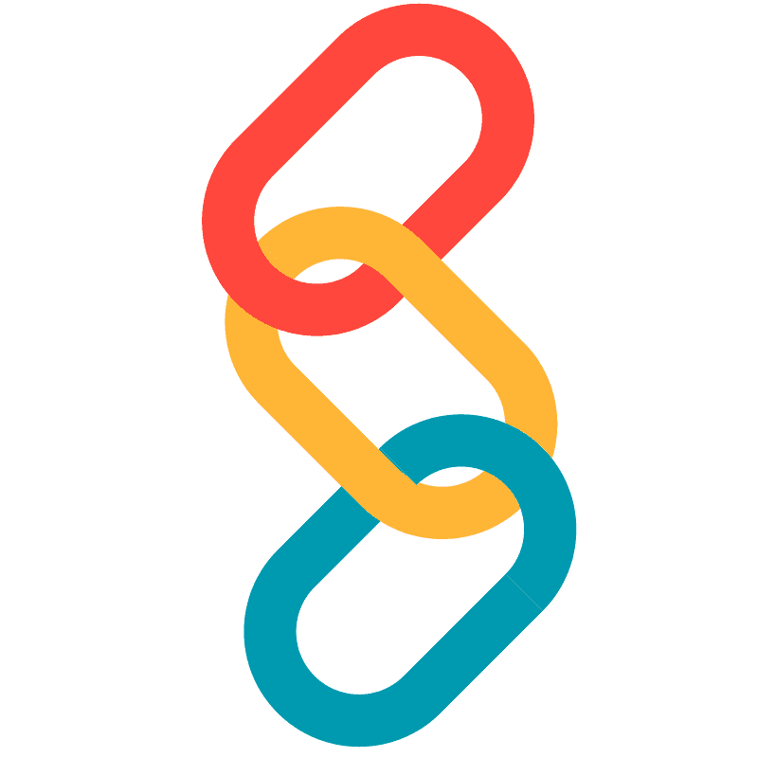  Curriculum Progression  Refer to long term plan and progression document  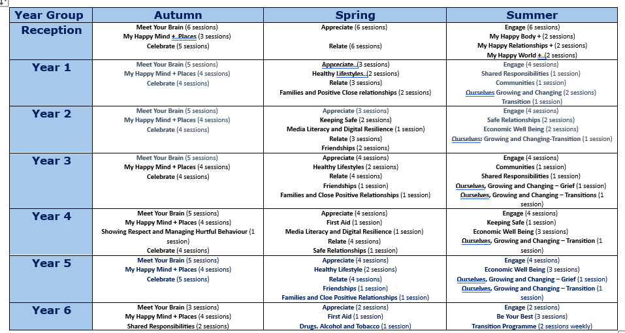
  Staff CPD  (Good Practice)  Staff CPD has taken place through staff meetings on the PSHE/RSE curriculum and the onboarding sessions for My Happy Mind. |  |   Approach to Assessment  Assessment in PSHE/RSE consists of bespoke criteria for each year group, which was derived from our progression document alongside the National curriculum. Within each year groups assessment documentation are statements that are linked to knowledge and skills which they will cover. Evidence of them meeting these criteria may be present in class scrap books, children’s individual My Happy Mind Journals and may have been witnessed by the class teacher. |  |  |   Meeting the Needs of all Pupils  Pupils are given additional support within lessons dependent on their individual needs. This can done on an individual or guided group basis. Children are supported through the use of adult support. Additional Online Safety Units are also available for teachers on Purple Mash Platform to allow teachers to adapt when necessary to meet the needs of the children within the cohort. |  |  |   Our Impact  Outcomes evidence a broad and balanced PSHE/RSE curriculum and demonstrate children’s acquisition of identified key knowledge relating to each of the identified national curriculum strands, as appropriate to key stage;  EYFS  - Self-regulation  - Managing self  - Building relationships  Key Stage 1 and 2  - Family and Relationships  - Safety and the Changing Body  - Health and wellbeing  - Citizenship  - Economic wellbeing  We measure the impact of our curriculum through the following methods:  - Assessing children’s understanding of theme linked vocabulary before and after the unit is taught.  - Assessment of pupil discussions about their learning.  - Quizzes through the My Happy Mind Programme

